**WinRetail AutoTask Utility User Overview**

**Step 1: Run Utility.** **Step 2: Click *Paste in Receipt* Button** **or** **Click *Import CSV* Button.**

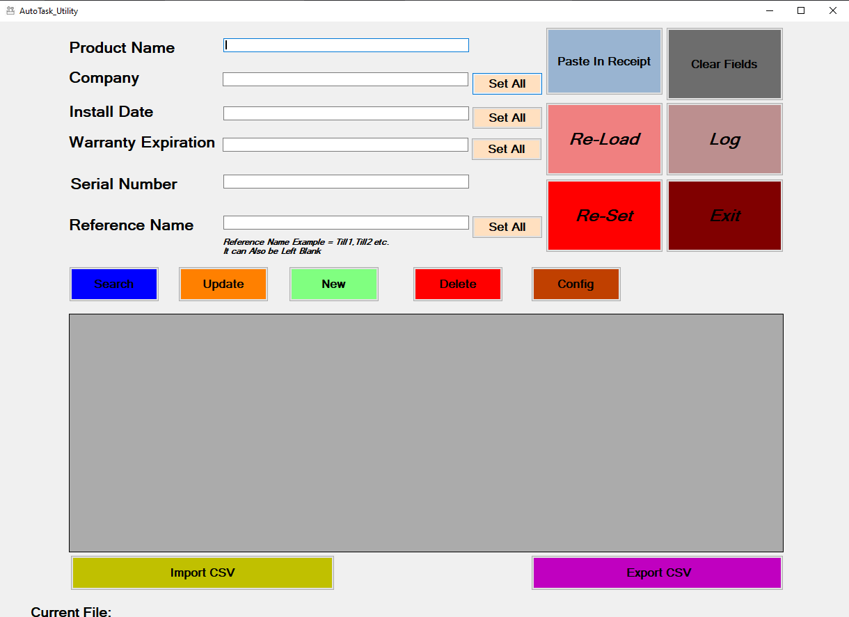 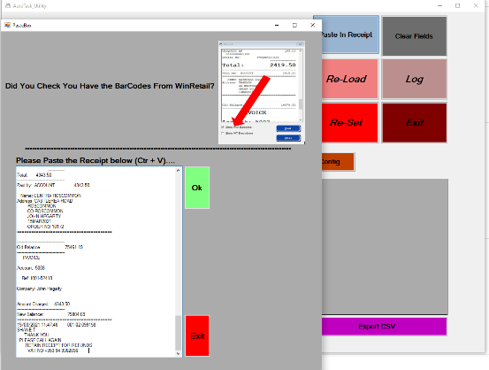 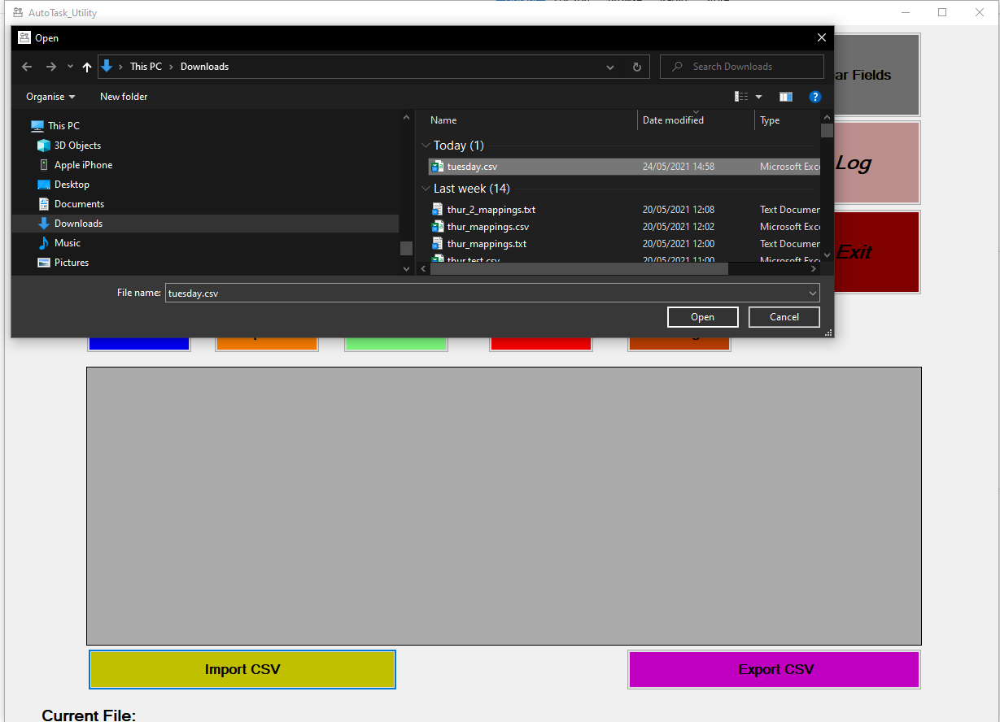

**Step 3: Use Utility to Search/Update/New/delete Step 4: Click *Export CSV* Button.**

